**TEAMDUTY Web-application**

Test Record

**By**

Mr. Manuchet Manoi 542115049

Mr. Saknarong Noipaksa 542115061

Department of Software Engineering

College of Arts, Media and Technology

Chiang Mai University

**Project Advisor**

______________________________________

**Aj. Jayakrit Hirisajja**

**Document History**

|  |  |  |  |  |  |  |  |
| --- | --- | --- | --- | --- | --- | --- | --- |
| **Document Name** | **Version** | **Status** | **Date** | **Viewable** | **Reviewer** | | **Responsible** |
| **Documents** | | | | | | | |
| TEAMDUTY - Web application - SRS v 0.1.docx | **Add Chapter 1**  - Objective  - Intended Audience and Reading Suggestions  - Project Scope | Draft | 15 May 2014 | MM,  SN,JH | | MM,  SN | MM,  SN |
| TEAMDUTY - Web application - SRS v 0.1.docx | **Add Chapter 2**  -Unittest Record  -Systemtest Record | Draft | 16 May 2014 | MM,  SN,JH | | MM,  SN | MM,  SN |
| TEAMDUTY - Web application - SRS v 0.1.docx | **Retest All Unittest & Systemtest** | Draft | 07 July 2014 | MM,  SN,JH | | MM,  SN | MM,  SN |
| TEAMDUTY - Web application - SRS v 1.0.docx | **Retest All Unittest & Systemtest** | Draft | 21 July 2014 | MM,  SN,JH | | MM,  SN | MM,  SN |
| TEAMDUTY - Web application - SRS v 2.0.docx | **Retest All Unittest & Systemtest** | Draft | 20 October 2014 | MM,  SN,JH | | MM,  SN | MM,  SN |

**\*MM = Manuchet Manoi**

**\*SN = Saknarong Noipaksa**

**\*JH = Jayakrit Hirisajja**

**Table of Contents**

Chapter One | Introduction 6

1.1 Purpose 6

1.2 Scope 6

1.3 Objective 6

1.4 Dependency Document 6

1.5 Test Duration 6

Chapter Two | TestRecord 7

2.1 Unittest 7

ControllerPackage 7

RepositoryPackage 33

ServicePackage 54

2.2 System test 57

2.2.1 Service request customer 57

Employer System Test case 01 (ESTC-01): 57

Employer System Test case 02 (ESTC-02): 59

Employer System Test case 03 (ESTC-03): 60

Employer System Test case 04 (ESTC-04): 61

Employer System Test case 05 (ESTC-05): 62

Employer System Test case 06 (ESTC-06): 63

Employer System Test case 07 (ESTC-07): 64

Employer System Test case 08 (ESTC-08): 65

Employer System Test case 09 (ESTC-09): 66

Employer System Test case 10 (ESTC-10): 67

Employer System Test case 11 (ESTC-11): 68

Employer System Test case 12 (ESTC-12): 69

Employer System Test case 13 (ESTC-13): 70

Employer System Test case 14 (ESTC-14): 71

Employer System Test case 15 (ESTC-15): 72

Employer System Test case 16 (ESTC-16): 73

Employer System Test case 17 (ESTC-17): 74

Employer System Test case 18 (ESTC-18): 75

Employer System Test case 19 (ESTC-19): 76

Employer System Test case 20 (ESTC-20): 77

Employer System Test case 21 (ESTC-21): 78

Employer System Test case 22 (ESTC-22): 79

Employer System Test case 23 (ESTC-23): 80

Employer System Test case 24 (ESTC-24): 81

2.2.1 Freelancer supply 82

Freelancer System Test case 01 (FSTC-01): 82

Freelancer System Test case 02 (FSTC-02): 84

Freelancer System Test case 03 (FSTC-03): 85

Freelancer System Test case 04 (FSTC-04): 86

Freelancer System Test case 05 (FSTC-05): 87

Freelancer System Test case 06 (FSTC-06): 88

Freelancer System Test case 07 (FSTC-07): 89

Freelancer System Test case 08 (FSTC-08): 90

Freelancer System Test case 09 (FSTC-09): 91

Freelancer System Test case 10 (FSTC-10): 92

Freelancer System Test case 11 (FSTC-11): 93

Freelancer System Test case 12 (FSTC-12): 94

Freelancer System Test case 13 (FSTC-13) 95

Freelancer System Test case 14 (FSTC-14) 96

Freelancer System Test case 15 (FSTC-15): 97

Freelancer System Test case 16 (FSTC-16): 98

Freelancer System Test case 17 (FSTC-17): 99

Freelancer System Test case 18 (FSTC-18): 100

Freelancer System Test case 19 (FSTC-19): 101

# Chapter One | Introduction

## 1.1 Purpose

The objectives of the test Record of TEAMDUTY – Webapplication system is to show result of test.And bring to approve software product

## 1.2 Scope

This test result describes the white box-testing and black-box testing are activities to defect the defects in the system and describes the system testing activities for testing a completely integrated system to verify that it meets the user requirements.

## 1.3 Objective

The objective of test result of TEAMDUTY – Webapplication system project are:

Show result of test and bring some problem that occer in test result to approve software final product.

## 1.4 Dependency Document

* Project Proposal
* Project Plan
* Software Requirement Specification
* Software Design Document
* Testing Document
* Test Plan  
  - Unit Test Document  
  - System Test Document
* Test Report  
  - Unit Test Document  
  - System Test Document
* Traceability Record
* Progress Status Report
* Change Report

## 1.5 Test Duration

|  |  |
| --- | --- |
| **Progress** | **Date and Duration** |
| 1 | **Perform date:** 16th May 2014 - 18th May 2014(Unit test, System test) **Duration:** 3 days and retest again on 6 – 7 July 2014 |
| 2 | **Perform date:** 15th October 2014 - 18th October 2014(Unit test, System test) **Duration:** 3 days |

# Chapter Two | TestRecord

## 2.1 Unittest

### ControllerPackage

**\*ControllerUnittest we use visual studio for check actionresult method can’t be not null to call view page. But we will use manual test to check Controller that call directly page will or not by test with manual browser\***

#### Class HomeController

##### Controller Unit Test Case 1# **Index()**

*TestTool :* Visual Studio 2012 (Unittest)

*TestMethod :*

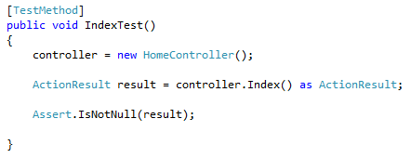

*TestResult :*

|  |  |  |  |
| --- | --- | --- | --- |
| ID | **Expected Result** | Actual Result | Pass/Fail |
| 1 | Pass | Pass | Pass |
| 2 | Fail | Fail | Pass |

*TestReferrence :*

#### Class AccountController

##### Controller Unit Test Case 2# Create()

*TestTool :* Visual Studio 2012 (Unittest)

*TestMethod :*

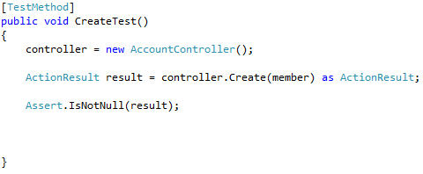

*TestResult :*

|  |  |  |  |
| --- | --- | --- | --- |
| ID | **Expected Result** | Actual Result | Pass/Fail |
| 1 | Pass | Pass | Pass |
| 2 | Fail | Fail | Pass |

*TestReferrence :*

**This TestCase Create Stub member to use in this Unittest case

public MyApplication.Member member { get; set; }

##### Controller Unit Test Case 3# ConfirmRegister()

*TestTool :* Visual Studio 2012 (Unittest)

*TestMethod :*

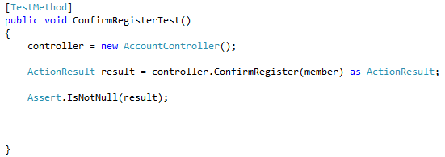

*TestResult :*

|  |  |  |  |
| --- | --- | --- | --- |
| ID | **Expected Result** | Actual Result | Pass/Fail |
| 1 | Pass | Pass | Pass |
| 2 | Fail | Fail | Pass |

*TestReferrence :*

**This TestCase Create Stub member to use in this Unittest case

public MyApplication.Member member { get; set; }

##### Controller Unit Test Case 4# Login()

*TestTool :* Visual Studio 2012 (Unittest)

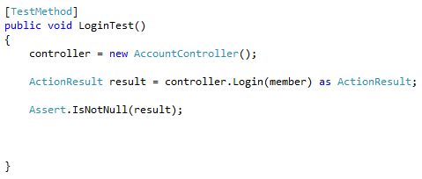*TestMethod :*

*TestResult :*

|  |  |  |  |
| --- | --- | --- | --- |
| ID | **Expected Result** | Actual Result | Pass/Fail |
| 1 | Pass | Pass | Pass |
| 2 | Fail | Fail | Pass |

*TestReferrence :*

**This TestCase Create Stub member to use in this Unittest case

public MyApplication.Member member { get; set; }

##### Controller Unit Test Case 5# ShowfreelancerTest ()

*TestTool :* Visual Studio 2012 (Unittest)

*TestMethod :*

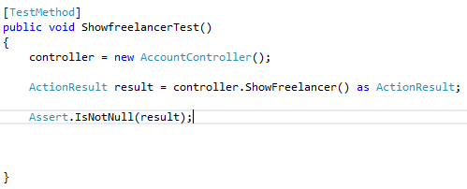

*TestResult :*

|  |  |  |  |
| --- | --- | --- | --- |
| ID | **Expected Result** | Actual Result | Pass/Fail |
| 1 | Pass | Pass | Pass |
| 2 | Fail | Fail | Pass |

*TestReferrence :*

**This TestCase Create Stub member to use in this Unittest case

public MyApplication.Member member { get; set; }

##### Controller Unit Test Case 6# ShowProfiles(int pid)

*TestTool :* Visual Studio 2012 (Unittest)

*TestMethod :*

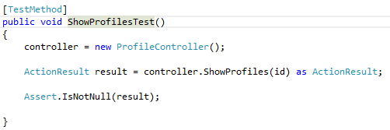

*TestResult :*

|  |  |  |  |
| --- | --- | --- | --- |
| ID | **Expected Result** | Actual Result | Pass/Fail |
| 1 | Pass | Pass | Pass |
| 2 | Fail | Fail | Pass |

*TestReferrence :*

**This TestCase Create Stub id to use in this Unittest case

public int id { get; set; }

##### Controller Unit Test Case 7# Logout ()

*TestTool :* Visual Studio 2012 (Unittest)

*TestMethod :*

*Can’t testable with unittest*

*TestResult :*

|  |  |  |  |
| --- | --- | --- | --- |
| ID | **Expected Result** | Actual Result | Pass/Fail |
| 1 | Pass | Fail | Pass |

*TestReferrence :* -

#### Class ProfileControler

##### Controller Unit Test Case 8# Profile()

*TestTool :* Visual Studio 2012 (Unittest)

*TestMethod :*

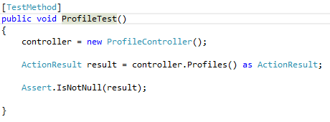

*TestResult :*

|  |  |  |  |
| --- | --- | --- | --- |
| ID | **Expected Result** | Actual Result | Pass/Fail |
| 1 | Pass | Pass | Pass |
| 2 | Fail | Fail | Pass |

*TestReferrence :*



##### Controller Unit Test Case 9# ShowProfiles(int pid)

*TestTool :* Visual Studio 2012 (Unittest)

*TestMethod :*



*TestResult :*

|  |  |  |  |
| --- | --- | --- | --- |
| ID | **Expected Result** | Actual Result | Pass/Fail |
| 1 | Pass | Pass | Pass |
| 2 | Fail | Fail | Pass |

*TestReferrence :*

**This TestCase Create Stub id to use in this Unittest case

public int id { get; set; }

#### Class BidControler

##### Controller Unit Test Case 10# Bidding()

*TestTool :* Visual Studio 2012 (Unittest)

*TestMethod :*

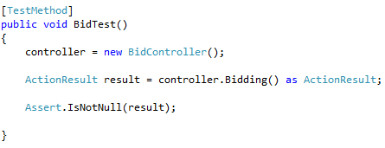

*TestResult :*

|  |  |  |  |
| --- | --- | --- | --- |
| ID | **Expected Result** | Actual Result | Pass/Fail |
| 1 | Pass | Pass | Pass |
| 2 | Fail | Fail | Pass |

*TestReferrence :*

**This TestCase Create Stub id to use in this Unittest case

public int id { get; set; }

##### Controller Unit Test Case 11# showBiddingList ()

*TestTool :* Visual Studio 2012 (Unittest)

*TestMethod :*

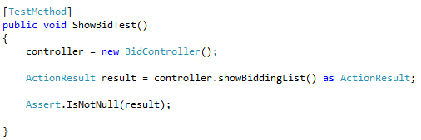

*TestResult :*

|  |  |  |  |
| --- | --- | --- | --- |
| ID | **Expected Result** | Actual Result | Pass/Fail |
| 1 | Pass | Pass | Pass |
| 2 | Fail | Fail | Pass |

*TestReferrence : *

##### Controller Unit Test Case 12# ShowProfilesFromBid (pid)

*TestTool :* Visual Studio 2012 (Unittest)

*TestMethod :*

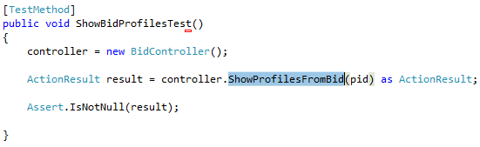

*TestResult :*

|  |  |  |  |
| --- | --- | --- | --- |
| ID | **Expected Result** | Actual Result | Pass/Fail |
| 1 | Pass | Pass | Pass |
| 2 | Fail | Fail | Pass |

*TestReferrence :*



**This TestCase Create Stub id to use in this Unittest case

public int pid { get; set; }

#### Class JobControler

##### Controller Unit Test Case 13# PostJob()

*TestTool :* Visual Studio 2012 (Unittest)

*TestMethod :*

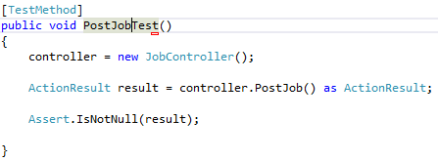

*TestResult :*

|  |  |  |  |
| --- | --- | --- | --- |
| ID | **Expected Result** | Actual Result | Pass/Fail |
| 1 | Pass | Pass | Pass |
| 2 | Fail | Fail | Pass |

*TestReferrence :*



##### Controller Unit Test Case 14# ShowJob()

*TestTool :* Visual Studio 2012 (Unittest)

*TestMethod :*

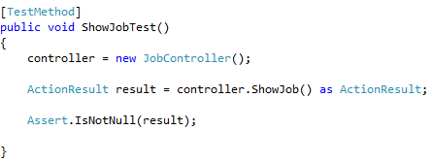

*TestResult :*

|  |  |  |  |
| --- | --- | --- | --- |
| ID | **Expected Result** | Actual Result | Pass/Fail |
| 1 | Pass | Fail | Fail |
| 2 | Fail | Fail | Fail |

*TestReferrence :*



##### Controller Unit Test Case 15# DeleteJobTest(id)

*TestTool :* Visual Studio 2012 (Unittest)

*TestMethod :*

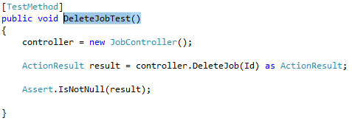

*TestResult :*

|  |  |  |  |
| --- | --- | --- | --- |
| ID | **Expected Result** | Actual Result | Pass/Fail |
| 1 | Pass | Pass | Pass |
| 2 | Fail | Fail | Pass |

*TestReferrence :*

**This TestCase Create Stub id to use in this Unittest case

public int Id { get; set; }

##### Controller Unit Test Case 16# GotoShowDetailCategoryJobTest()

*TestTool :* Visual Studio 2012 (Unittest)

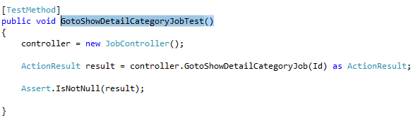*TestMethod :*

*TestResult :*

|  |  |  |  |
| --- | --- | --- | --- |
| ID | **Expected Result** | Actual Result | Pass/Fail |
| 1 | Pass | Pass | Pass |
| 2 | Fail | Fail | Pass |

*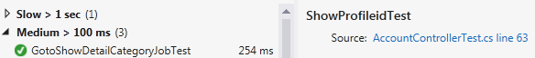TestReferrence :*

**This TestCase Create Stub id to use in this Unittest case

public int Id { get; set; }

##### Controller Unit Test Case 17# showJobRequest ()

*TestTool :* Visual Studio 2012 (Unittest)

*TestMethod :*

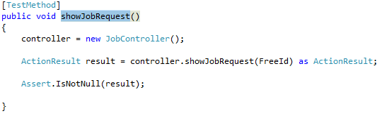

*TestResult :*

|  |  |  |  |
| --- | --- | --- | --- |
| ID | **Expected Result** | Actual Result | Pass/Fail |
| 1 | Pass | Pass | Pass |
| 2 | Fail | Fail | Pass |

*TestReferrence :*

**This TestCase Create Stub id to use in this Unittest case

public int FreeId { get; set; }

public int JobId { get; set; }

#### Class DisplayJobControler

##### Controller Unit Test Case 18# ShowDetailCategoryJobTest (int jid)

*TestTool :* Visual Studio 2012 (Unittest)

*TestMethod :*

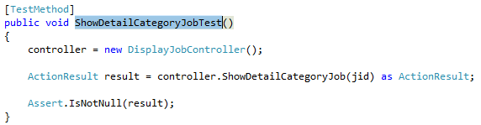

*TestResult :*

|  |  |  |  |
| --- | --- | --- | --- |
| ID | **Expected Result** | Actual Result | Pass/Fail |
| 1 | Pass | Pass | Pass |
| 2 | Fail | Fail | Pass |

*TestReferrence :*

**This TestCase Create Stub id to use in this Unittest case

public int Id { get; set; }

#### Class NotificationControler

##### Controller Unit Test Case 19# FreeNotificationJob(int uid,int EmployerId,int jobId)

*TestTool :* Google Chorme

*TestMethod*  *Can’t testable with unittest but can know id of request in title bar*

*TestResult :*

|  |  |  |  |
| --- | --- | --- | --- |
| ID | **Expected Result** | Actual Result | Pass/Fail |
| 1 | Pass | Fail | Pass |

*TestReferrence :* -

##### Controller Unit Test Case 20# EmNotiTest()

*TestTool :* Visual Studio 2012 (Unittest)

*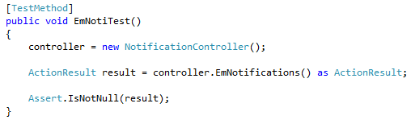TestMethod*

*TestResult :*

|  |  |  |  |
| --- | --- | --- | --- |
| ID | **Expected Result** | Actual Result | Pass/Fail |
| 1 | Pass | Pass | Pass |

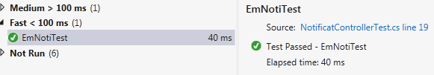*TestReferrence :*

##### Controller Unit Test Case 21# FreeNotiTest()

*TestTool :* Visual Studio 2012 (Unittest)

*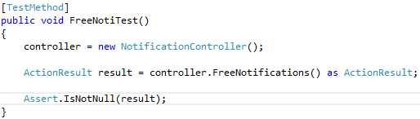TestMethod*

*TestResult :*

|  |  |  |  |
| --- | --- | --- | --- |
| ID | **Expected Result** | Actual Result | Pass/Fail |
| 1 | Pass | Pass | Pass |

*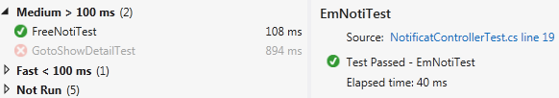TestReferrence :*

##### Controller Unit Test Case 22# GotoShowDetailTest()

*TestTool :* Visual Studio 2012 (Unittest)

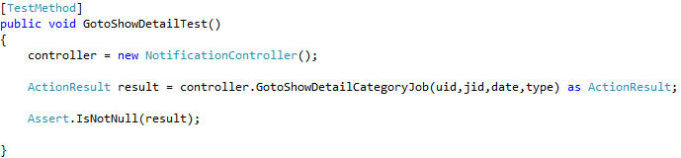*TestMethod*

*TestResult :*

|  |  |  |  |
| --- | --- | --- | --- |
| ID | **Expected Result** | Actual Result | Pass/Fail |
| 1 | Pass | Pass | Pass |

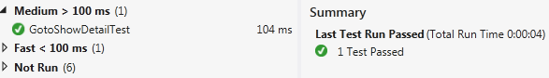*TestReferrence :*

**This TestCase Create Stub userid, jobid, date, type to use in this Unittest case

public int uid { get; set; }

public int jid { get; set; }

public string date { get; set; }

public string type { get; set; }

##### Controller Unit Test Case 23# ConfirmprojectTest()

*TestTool :* Visual Studio 2012 (Unittest)

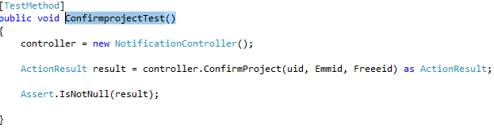*TestMethod*

*TestResult :*

|  |  |  |  |
| --- | --- | --- | --- |
| ID | **Expected Result** | Actual Result | Pass/Fail |
| 1 | Pass | Pass | Pass |

*TestReferrence :*

**This TestCase Create Stub userid, jobid, date, type to use in this Unittest case

public int uid { get; set; }

public int Emmid { get; set; }

public int Freeeid { get; set; }

#### Class ProjectControler

##### Controller Unit Test Case 24# CreateProject(int JobId, int EmId, int FreeId)

*TestTool :* Google Chorme

*TestMethod*  *Can’t testable with unittest but can know id of request in title bar*

*TestResult :*

|  |  |  |  |
| --- | --- | --- | --- |
| ID | **Expected Result** | Actual Result | Pass/Fail |
| 1 | Pass | Pass | Pass |

*TestReferrence :* -

##### Controller Unit Test Case 25# ShowProjectTesT()

*TestTool :* Visual Studio 2012

*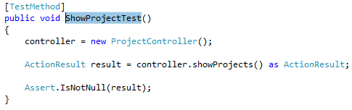TestMethod*

*TestResult :*

|  |  |  |  |
| --- | --- | --- | --- |
| ID | **Expected Result** | Actual Result | Pass/Fail |
| 1 | Pass | Pass | Pass |

*TestReferrence :*

##### Controller Unit Test Case 26# ProressofProjectTesT(int jobId)

*TestTool :* Visual Studio 2012

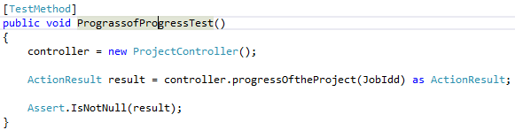*TestMethod*

*TestResult :*

|  |  |  |  |
| --- | --- | --- | --- |
| ID | **Expected Result** | Actual Result | Pass/Fail |
| 1 | Pass | Pass | Pass |

*TestReferrence :*

##### Controller Unit Test Case 27# Upload(Contextfile)

*TestTool :* Google Chorme

*TestMethod*

*Can’t testable direct page with unittest but can know file name of request in browser page*

*TestResult :*

|  |  |  |  |
| --- | --- | --- | --- |
| ID | **Expected Result** | Actual Result | Pass/Fail |
| 1 | Pass | Pass | Pass |

*TestReferrence :* -

##### Controller Unit Test Case 28# DownloadDirectTest(bool)

*TestTool :* Visual Studio 2012

*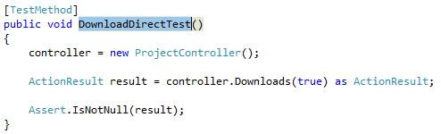TestMethod* :

*TestResult :*

|  |  |  |  |
| --- | --- | --- | --- |
| ID | **Expected Result** | Actual Result | Pass/Fail |
| 1 | Pass | Pass | Pass |

*TestReferrence :*

### RepositoryPackage

#### Class AccountRepository

**Repository Unit Test Case 1**#

##### public IEnumerable<Member> GetUsers()

*TestTool :* Visual Studio 2012 (Unittest)

*TestMethod :*

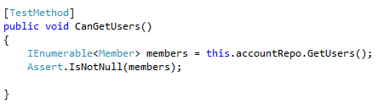

*TestResult :*

|  |  |  |  |
| --- | --- | --- | --- |
| ID | **Expected Result** | Actual Result | Pass/Fail |
| 1 | Pass | Pass | Pass |
| 2 | Pass | Pass | Pass |

*TestReferrence :*

**

**Repository Unit Test Case 2**#

##### public void InsertUser(Member user),public Member GetUserByID(int userId)

*TestTool :* Visual Studio 2012 (Unittest)

*TestMethod :*

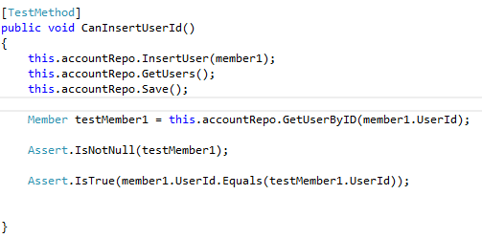

*TestResult :*

|  |  |  |  |
| --- | --- | --- | --- |
| ID | **Expected Result** | Actual Result | Pass/Fail |
| 1 | Pass | Pass | Pass |
| 2 | Pass | Pass | Pass |

*TestReferrence :*



**Repository Unit Test Case 3**#

##### public void InsertUser(Member user), public Member GetUserByEmail(string email)

*TestTool :* Visual Studio 2012 (Unittest)

*TestMethod :* 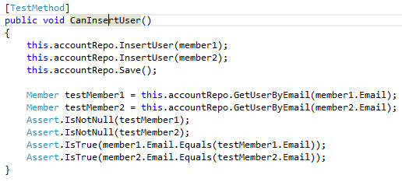

*TestResult :*

|  |  |  |  |
| --- | --- | --- | --- |
| ID | **Expected Result** | Actual Result | Pass/Fail |
| 1 | Pass | Pass | Pass |
| 2 | Pass | Pass | Pass |

*TestReferrence :*

**Repository Unit Test Case 4**#

##### public void Save()

*TestTool :* Visual Studio 2012 (Unittest)

*TestMethod :*

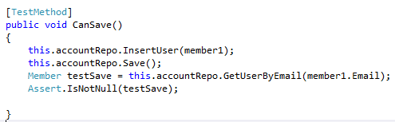

*TestResult :*

|  |  |  |  |
| --- | --- | --- | --- |
| ID | **Expected Result** | Actual Result | Pass/Fail |
| 1 | Pass | Pass | Pass |
| 2 | Pass | Pass | Pass |

*TestReferrence :*

#### Class ProfileRepository

**Repository Unit Test Case 5**#

##### public IEnumerable<Profile> GetProfile()

*TestTool :* Visual Studio 2012 (Unittest)

*TestMethod :*

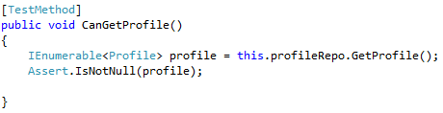

*TestResult :*

|  |  |  |  |
| --- | --- | --- | --- |
| ID | **Expected Result** | Actual Result | Pass/Fail |
| 1 | Pass | Pass | Pass |

*TestReferrence :*



**Repository Unit Test Case 6**#

##### public void InsertProfile(Profile profile), public Profile GetProfileByID(int profileId)

*TestTool :* Visual Studio 2012 (Unittest)

*TestMethod :*

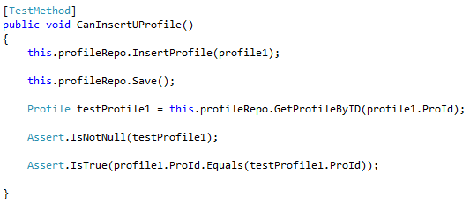

*TestResult :*

|  |  |  |  |
| --- | --- | --- | --- |
| ID | **Expected Result** | Actual Result | Pass/Fail |
| 1 | Pass | Pass | Pass |

*TestReferrence :*



**Repository Unit Test Case 7**#

##### public void UpdateProfile(Profile profile), public Profile GetProfileByID(int profileId)

*TestTool :* Visual Studio 2012 (Unittest)

*TestMethod :*

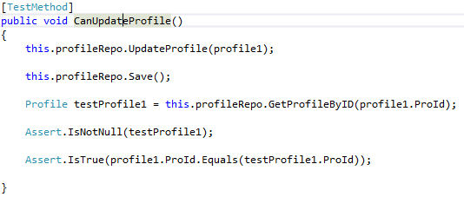

*TestResult :*

|  |  |  |  |
| --- | --- | --- | --- |
| ID | **Expected Result** | Actual Result | Pass/Fail |
| 1 | Pass | Pass | Pass |

*TestReferrence :*



**Repository Unit Test Case 8**#

##### public void DeleteProfile(Profile profile);

*TestTool :* Visual Studio 2012 (Unittest)

*TestMethod :*

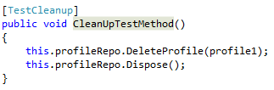

*TestResult :*

|  |  |  |  |
| --- | --- | --- | --- |
| ID | **Expected Result** | Actual Result | Pass/Fail |
| 1 | Pass | Pass | Pass |

*TestReferrence :*



#### Class JobRepository

**Repository Unit Test Case 9**#

##### public IEnumerable<Job> GetJobs()

*TestTool :* Visual Studio 2012 (Unittest)

*TestMethod :*

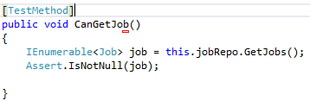

*TestResult :*

|  |  |  |  |
| --- | --- | --- | --- |
| ID | **Expected Result** | Actual Result | Pass/Fail |
| 1 | Pass | Pass | Pass |

*TestReferrence :*



**Repository Unit Test Case 10**#

##### public void InsertJob(Job job), public Job GetJobByID(int jobId)

*TestTool :* Visual Studio 2012 (Unittest)

*TestMethod :*

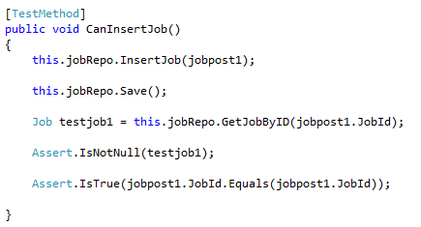

*TestResult :*

|  |  |  |  |
| --- | --- | --- | --- |
| ID | **Expected Result** | Actual Result | Pass/Fail |
| 1 | Pass | Pass | Pass |

*TestReferrence :*



**Repository Unit Test Case 11**#

##### public void Save()

*TestTool :* Visual Studio 2012 (Unittest)

*TestMethod :*

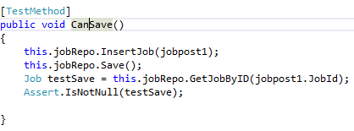

*TestResult :*

|  |  |  |  |
| --- | --- | --- | --- |
| ID | **Expected Result** | Actual Result | Pass/Fail |
| 1 | Pass | Pass | Pass |

*TestReferrence :*



#### Class BidRepository

##### Repository Unit Test Case 12# public IEnumerable<Bid> GetBids()

*TestTool :* Visual Studio 2012 (Unittest)

*TestMethod :*

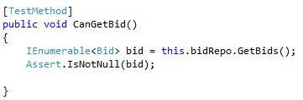

*TestResult :*

|  |  |  |  |
| --- | --- | --- | --- |
| ID | **Expected Result** | Actual Result | Pass/Fail |
| 1 | Pass | Pass | Pass |
| 2 | Pass | Pass | Pass |

*TestReferrence :*



##### Repository Unit Test Case 13# public void InsertBid(Bid bid) , public Bid GetBidById(int bidId)

*TestTool :* Visual Studio 2012 (Unittest)

*TestMethod :*

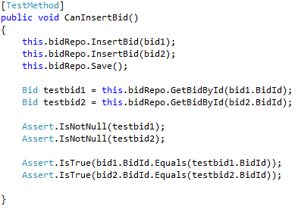

*TestResult :*

|  |  |  |  |
| --- | --- | --- | --- |
| ID | **Expected Result** | Actual Result | Pass/Fail |
| 1 | Pass | Pass | Pass |
| 2 | Pass | Pass | Pass |

*TestReferrence :*



##### Repository Unit Test Case 14# public void Save()

*TestTool :* Visual Studio 2012 (Unittest)

*TestMethod :*

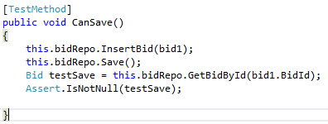

*TestResult :*

|  |  |  |  |
| --- | --- | --- | --- |
| ID | **Expected Result** | Actual Result | Pass/Fail |
| 1 | Pass | Pass | Pass |
| 2 | Pass | Pass | Pass |

*TestReferrence :*



#### Class DisplayBidRepository

##### Repository Unit Test Case 15# CanGetBidDisplay()

*TestTool :* Visual Studio 2012 (Unittest)

*TestMethod :*

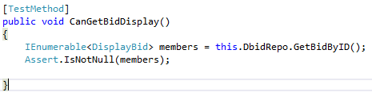

*TestResult :*

|  |  |  |  |
| --- | --- | --- | --- |
| ID | **Expected Result** | Actual Result | Pass/Fail |
| 1 | Pass | Pass | Pass |
| 2 | Pass | Pass | Pass |

*TestReferrence :*



#### Class NotificationRepository

##### Repository Unit Test Case 16# CanInsertNotiId()

*TestTool :* Visual Studio 2012 (Unittest)

*TestMethod :*

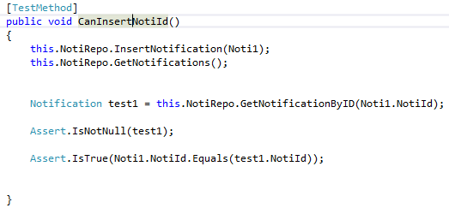

*TestResult :*

|  |  |  |  |
| --- | --- | --- | --- |
| ID | **Expected Result** | Actual Result | Pass/Fail |
| 1 | Pass | Pass | Pass |
| 2 | Pass | Pass | Pass |

*TestReferrence :*



##### Repository Unit Test Case 17# CanGetNoti()

*TestTool :* Visual Studio 2012 (Unittest)

*TestMethod :*

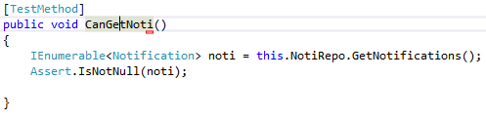

*TestResult :*

|  |  |  |  |
| --- | --- | --- | --- |
| ID | **Expected Result** | Actual Result | Pass/Fail |
| 1 | Pass | Pass | Pass |
| 2 | Pass | Pass | Pass |

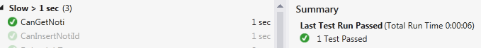*TestReferrence :*

##### Repository Unit Test Case 18# CanSave ()

*TestTool :* Visual Studio 2012 (Unittest)

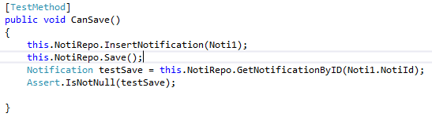*TestMethod :*

*TestResult :*

|  |  |  |  |
| --- | --- | --- | --- |
| ID | **Expected Result** | Actual Result | Pass/Fail |
| 1 | Pass | Pass | Pass |
| 2 | Pass | Pass | Pass |

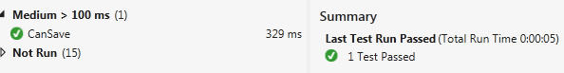*TestReferrence :*

#### Class ProjectRepository

##### Repository Unit Test Case 18# CanInsertProject()

*TestTool :* Visual Studio 2012 (Unittest)

*TestMethod :*

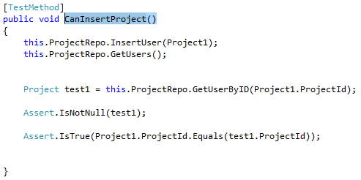

*TestResult :*

|  |  |  |  |
| --- | --- | --- | --- |
| ID | **Expected Result** | Actual Result | Pass/Fail |
| 1 | Pass | Pass | Pass |

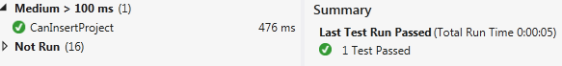*TestReferrence :*

##### Repository Unit Test Case 19# CanGetProject()

*TestTool :* Visual Studio 2012 (Unittest)

*TestMethod :*

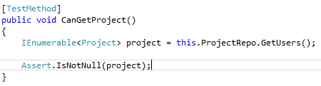

*TestResult :*

|  |  |  |  |
| --- | --- | --- | --- |
| ID | **Expected Result** | Actual Result | Pass/Fail |
| 1 | Pass | Pass | Pass |

*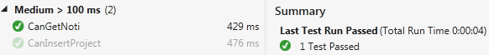TestReferrence :*

##### Repository Unit Test Case 20# CanSaveProject()

*TestTool :* Visual Studio 2012 (Unittest)

*TestMethod :*

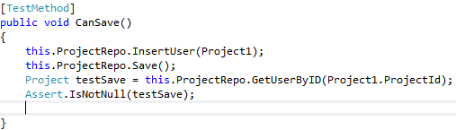

*TestResult :*

|  |  |  |  |
| --- | --- | --- | --- |
| ID | **Expected Result** | Actual Result | Pass/Fail |
| 1 | Pass | Pass | Pass |

*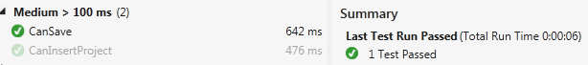TestReferrence :*

### ServicePackage

#### Class AccountService

**Service Unit Test Case 1#**

public bool IsValid(string username, string password)

*TestTool :* Visual Studio 2012 (Unittest)

*TestMethod :*

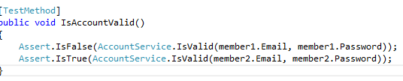

*TestResult :*

|  |  |  |  |
| --- | --- | --- | --- |
| ID | **Expected Result** | Actual Result | Pass/Fail |
| 1 | Fail | Fail | Pass |
| 2 | Pass | Pass | Pass |

*TestReferrence :*



**Service Unit Test Case 2#**

public bool IsExistEmail(String Email)

*TestTool :* Visual Studio 2012 (Unittest)

*TestMethod :*

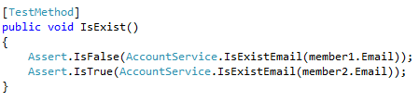

*TestResult :*

|  |  |  |  |
| --- | --- | --- | --- |
| ID | **Expected Result** | Actual Result | Pass/Fail |
| 1 | Fail | Fail | Pass |
| 2 | Pass | Pass | Pass |

*TestReferrence :*



**Service Unit Test Case 3#**

#### Class EmailService

*TestTool :* Visual Studio 2012 (Unittest)

*TestMethod :*

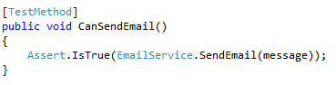

*TestResult :*

Can send mail Directly to Email that input on previous

*TestReferrence :*



# 2.2 System test

## 2.2.1 Service request customer

### Employer System Test case 01 (ESTC-01):

*Service request customer* can be Register and select type of user as *service request customer*

**Description:**

This system test case testing for E-URS-01. *service request customer* can be Register and select type of user as *service request customer*

**Test Script:**

1**.** Click “Register” button in first page of web-application

2. System Provide UI system provide UI to input Email, select type of user, password, confirm password

3. Select type of user = Employer, input Email Address input password and Comfirm password and click Create

4. The System save data type of user, Email Address, input password and Confirm password to database

5. The System bring *service request customer* to index mainpage

**Test Case:**

|  |  |  |  |
| --- | --- | --- | --- |
| ID | **Expected Result** | Actual Result | Pass/Fail |
| 1 | System bring *service request customer* to web-application mainpage | Pass | Pass |
| 2 | System display error message near Email input box and *service request customer* need to reinput again | System display error message near Email input box and need to reinput again | Pass |
| 3 | System display error message near Email input box and *service request customer* need to reinput again | System display error message near Email input box and need to reinput again | Pass |
| 4 | System display error message near Email input box and *service request customer* need to reinput again | System display error message near Email input box and need to reinput again | Pass |

|  |  |  |  |
| --- | --- | --- | --- |
| ID | **Expected Result** | Actual Result | Pass/Fail |
| 5 | System display error message near Confirm password input box and *service request customer* need to reinput again | System display error message near Email input box and need to reinput again | Pass |
| 6 | System display error message near Email input box and *service request customer* need to reinput again | System display error message near Email input box and need to reinput again | Pass |
| 7 | System display error message near Email input box and *service request customer* need to reinput again | System display error message near Email input box and need to reinput again | Pass |

### Employer System Test case 02 (ESTC-02):

*Service request customer* can be ConfirmRegister via email address after Register

**Description:**

This system test case testing for E-URS – 02:*service request customer* can be ConfirmRegister in their Email that they input on previously

**Prerequisite:**

*Service request customer* need to Register first

**Test Script:**

1**.** Login to Email address that register in previously (in this case use pureman9@gmail.com)

2. System will send link of ConfirmRegister to Email Address that registered on previously

3. Click link in Email address

4. The System bring *service request customer* to input Username & ConfirmRegisterCode

5. The System bring *service request customer* to index mainpage

**Test Case:**

|  |  |  |  |
| --- | --- | --- | --- |
| ID | **Expected Result** | Actual Result | Pass/Fail |
| 1 | System bring *service request customer* to web-application mainpage | System bring to web-application mainpage | Pass |
| 2 | System display error message near Username input box and *service request customer* need to reinput again | User need to reinput ConfirmPassword again | Fail |
| 3 | System display error message near Username input box and *service request customer* need to reinput again | User need to reinput ConfirmPassword again | Fail |
| 4 | System display error message near ConfirmRegisterCode input box and *service request customer* need to reinput again | User need to reinput ConfirmPassword again | Fail |

### Employer System Test case 03 (ESTC-03):

*Service request customer* can be Login to use Web-Application

**Description:**

This system test case testing for E-URS – 03:*service request customer* can be Login to use Web Application after get user account.

**Prerequisite:**

*Service request customer* need to ConfirmRegister first

**Test Script:**

1**.** Click “Login” button in first page of web-application

2. System Provide UI system provide UI to input Username & Password

3. Select input Username & password and click confirm.

4. The System bring *service request customer* to *service request customer* mainpage

**Test Case:**

|  |  |  |  |
| --- | --- | --- | --- |
| ID | **Expected Result** | Actual Result | Pass/Fail |
| 1 | System bring *service request customer* to *service request customer* mainpage | System bring *service request customer* to *service request customer* mainpage | Pass |
| 2 | System display error message and *service request customer* need to reinput again | System display error message and *service request customer* need to reinput again | Pass |
| 3 | System display error message and *service request customer* need to reinput again | System display error message and *service request customer* need to reinput again | Pass |
| 4 | System display error message and *service request customer* need to reinput again | System display error message and *service request customer* need to reinput again | Pass |
| 5 | System display error message and *service request customer* need to reinput again | System display error message and *service request customer* need to reinput again | Pass |

### Employer System Test case 04 (ESTC-04):

*Service request customer* can manage to add or edit Picture, Name, Company name, Address, Introduce yourself, and Telephone number in profile detail as *service request customer*.

**Description:**

This system test case testing for E-URS – 04:The *service request customer* can manage to add or edit Picture, Name, Company name, Address, Introduce yourself, and Telephone number in profile detail as *service request customer*.

**Prerequisite:**

*Service request customer* need to Login to using system first

**Test Script:**

1**.** Click “Login” button in first page of web-application

2. System Provide UI system provide UI to input Username & Password

3. Select input Username & password and click confirm.

4. The System bring *service request customer* to *service request customer* mainpage

5. Click “Profile Here” to add or edit Profile

6. Input Name, Company name, Address, Introduce yourself, and Telephone number in to profile page and Browse picture to profile

7. System Update the recipe detail to database

**Test Case**

|  |  |  |  |
| --- | --- | --- | --- |
| ID | **Expected Result** | Actual Result | Pass/Fail |
| 1 | System bring *service request customer* to *service request customer* mainpage | System bring *service request customer* to *service request customer* mainpage | Pass |
| 2 | System bring *service request customer* to *service request customer* mainpage | System bring *service request customer* to *service request customer* mainpage | Pass |
| 3 | System display error message and *service request customer* need to reinput again | System display error message and *service request customer* need to reinput again | Pass |
| 4 | System display error message and *service request customer* need to reinput again | System display error message and *service request customer* need to reinput again | Pass |

### Employer System Test case 05 (ESTC-05):

*Service request customer* can be Logout from web application

**Description:**

This system test case testing for E-URS – 05:*service request customer* can be Logout from web application

**Prerequisite:**

*Service request customer* need to Login to using system first

**Test Script:**

1. *service request customer* clicks logout.

2. *service request customer* logouted out of system

**Test Case:**

|  |  |  |  |
| --- | --- | --- | --- |
| ID | **Expected Result** | Actual Result | Pass/Fail |
| 1 | The *service request customer* logging out from system and redirect first main page. | logouted from system and redirect first main page. | Pass |

### Employer System Test case 06 (ESTC-06):

*Service request customer* can Request Password form system

**Description:**

This system test case testing for E-URS – 06:*service request customer* can be ask their password form system if they forgot

**Prerequisite:**

*Service request customer* need to ConfirmRegister first

**Test Script:**

1**.** Click “Login” button in first page of web-application

2. System Provide UI system provide UI to input Username & Password and link below submit show that “Are you forget password”

3. Select link “Are you forget Password”

4. The System bring *service request customer* to *forgetPassword Page*

5*.* In *forgetPassword Page*. System Provide UI system provide UI to input Username & ConfirmRegisterCode

6. Input username & ConfirmRegisterCode and submit it

**Test Case:**

|  |  |  |  |
| --- | --- | --- | --- |
| ID | **Expected Result** | Actual Result | Pass/Fail |
| 1 | System bring *service request customer* to *service request customer* mainpage | System bring *service request customer* to *service request customer* mainpage | Pass |
| 2 | System display error message and *service request customer* need to reinput again | System display error message and *service request customer* need to reinput again | Pass |
| 3 | System display error message and *service request customer* need to reinput again | System display error message and *service request customer* need to reinput again | Pass |

### Employer System Test case 07 (ESTC-07):

*Service request customer* can post job and Detail as Project Name, Budget, Information, skill required and Software role categories to system that show to both of user as *service request customer* and *freelance supply*.

**Description:**

This system test case testing for E-URS – 07:The ***service request customer*** can post job and Detail as Project Name, Budget, Information, skill required and Software role categories to system that show to both of user as *service request customer* and *freelance supply*.

**Prerequisite:**

*Service request customer* need to Login to using system first

**Test Script:**

1**.** Click “Login” button in first page of web-application

2. System Provide UI system provide UI to input Username & Password

3. Select input Username & password and click confirm.

4. The System bring *service request customer* to *service request customer* mainpage

5. Click “Project Here” to add Project

6. Detail as Project Name, Budget, Information, skill required and and Software role categories to system

7. System Update the recipe detail to database

**Test Case:**

|  |  |  |  |
| --- | --- | --- | --- |
| ID | **Expected Result** | Actual Result | Pass/Fail |
| 1 | System bring *service request customer* to *service request customer* mainpage | System bring *service request customer* to *service request customer* mainpage | Pass |
| 2 | System bring *service request customer* to *service request customer* mainpage | System bring *service request customer* to *service request customer* mainpage | Pass |
| 3 | System display error message and *service request customer* need to reinput again | System display error message and *service request customer* need to reinput again | Pass |
| 4 | System display error message and *service request customer* need to reinput again | System display error message and *service request customer* need to reinput again | Pass |

### Employer System Test case 08 (ESTC-08):

*Service request customer* can view Picture Name, Skill, and Address, Introduce yourself, and Telephone number in Profile detail of freelancer.

**Description:**

This system test case testing for E-URS – 08:The ***service request customer*** can view Picture Name, Skill, and Address, Introduce yourself, Skill required and Telephone number in Profile detail of freelancer.

**Prerequisite:**

*Service request customer* need to Login to using system first

**Test Script:**

1**.** Click “Login” button in first page of web-application

2. System Provide UI system provide UI to input Username & Password

3. Select input Username & password and click confirm.

4. The System bring *service request customer* to *service request customer* mainpage

5. Click “find Freelancer Here” to see list of Freelancer

6. Click “See freelancer”

7. *service request customer* see freelancer Detail as Picture Name, Skill, and Address, Introduce yourself, Skill required and Telephone number to system

8. System Update the recipe detail to database

**Test Case:**

|  |  |  |  |
| --- | --- | --- | --- |
| ID | **Expected Result** | Actual Result | Pass/Fail |
| 1 | Display Freelancer  Name : = Manuchet Manoi  Company name : =Perfect.vc  Address : =56 m.4 muang chiangmai 50133  Skill Required : = HTML  Introduce yourself : =Dev  Telephone number : =0855678909  Browse Pic : man.jpg | Display Freelancer  Name : = Manuchet Manoi  Company name : =Perfect.vc  Address : =56 m.4 muang chiangmai 50133  Skill Required : = HTML  Introduce yourself : =Dev  Telephone number : =0855678909  Browse Pic : man.jpg | Pass |

### Employer System Test case 09 (ESTC-09):

*Service request customer* can view posted job list in system.

**Description:**

This system test case testing for E-URS – 08:The ***service request customer*** can view posted job list in system.

**Prerequisite:**

*Service request customer* need to Login to using system first

**Test Script:**

1**.** Click “Login” button in first page of web-application

2. System Provide UI system provide UI to input Username & Password

3. Select input Username & password and click confirm.

4. The System bring *service request customer* to *service request customer* mainpage

5. Click “total job” to see list of job in system

6. Click “See more”

7. *service request customer* see job Detail as Project Name, Budget, Information, skill required and Software role categories

**Test Case:**

|  |  |  |  |
| --- | --- | --- | --- |
| ID | **Expected Result** | Actual Result | Pass/Fail |
| 1 | Display Job  Name : Manuchet Manoi  Address : 56 m.4 muang chiangmai 50133  Introduce yourself : Dev kub pom  Telephone number : 0855678922  Browse Pic : man.jpg | Display Job  Name : Manuchet Manoi  Address : 56 m.4 muang chiangmai 50133  Introduce yourself : Dev kub pom  Telephone number : 0855678922  Browse Pic : man.jpg | Pass |

### Employer System Test case 10 (ESTC-10):

*Service request customer* can view list of bidder in each project include budget & bidding detail

**Description:**

This system test case testing for E-URS – 10:The ***service request customer*** can view list of bidder in each project include budget & bidding detail

**Prerequisite:**

*Service request customer* need to Login to using system first

**Test Script:**

1**.** Click “Login” button in first page of web-application

2. System Provide UI system provide UI to input Username & Password

3. Select input Username & password and click confirm.

4. The System bring *service request customer* to *service request customer* mainpage

5. Click “total job” to see list of job in system

6. Click “This job”

7. *service request customer* see Bid Detail as Budget , Software role Require and project owner

**Test Case:**

|  |  |  |  |
| --- | --- | --- | --- |
| ID | **Expected Result** | Actual Result | Pass/Fail |
| 1 | Display Bid Below jobdetail as Bid Detail as Budget , Software role Require and project owner | Display Bid Below jobdetail as Bid Detail as Budget , Software role Require and project owner | Pass |

### Employer System Test case 11 (ESTC-11):

*Service request customer* can request freelancer that come to bidding their (***service request customer***) project

**Description:**

This system test case testing for E-URS – 11:The ***service request customer*** can request freelancer that come to bidding their (***service request customer***) project

**Prerequisite:**

*Service request customer* need to Login to using system first

**Test Script:**

1**.** Click “Login” button in first page of web-application

2. System Provide UI system provide UI to input Username & Password

3. Select input Username & password and click confirm.

4. The System bring *service request customer* to *service request customer* mainpage

5. Click “total job” to see list of job in system

6. Click “See more”

7. *service request customer* click request in bidder list

**Test Case:**

|  |  |  |  |
| --- | --- | --- | --- |
| ID | **Expected Result** | Actual Result | Pass/Fail |
| 1 | ShowSuccess request bidder after request | ShowSuccess request bidder after request | Pass |

### Employer System Test case 12 (ESTC-12):

*Service request customer* can view successes project in *freelance supply* profile.

**Description:**

This system test case testing for E-URS – 12:The ***service request customer*** can view successes project in *freelance supply* profile.

**Prerequisite:**

*Service request customer* need to Login to using system first

**Test Script:**

1**.** Click “Login” button in first page of web-application

2. System Provide UI system provide UI to input Username & Password

3. Select input Username & password and click confirm.

4. The System bring *service request customer* to *service request customer* mainpage

5. Click “ShowFreelancer” to see list of Freelancer in system

6. Click “See more”

7. *service request customer* click SeeProfile in Freelancer list

**Test Case:**

|  |  |  |  |
| --- | --- | --- | --- |
| ID | **Expected Result** | Actual Result | Pass/Fail |
| 1 | Display show Achievement project that Finished = “MobileApplication” below Achievment title | Display show Achievement project that Finished = “MobileApplication” below Achievment title | Pass |

### Employer System Test case 13 (ESTC-13):

*Service request customer* can search job list in service request customer management Page

**Description:**

This system test case testing for E-URS – 12:The ***service request customer*** can search job list in service request customer management Page

**Prerequisite:**

*service request customer* need to Login to using system first

**Test Script:**

1**.** Click “Login” button in first page of web-application

2. System Provide UI system provide UI to input Username & Password

3. Select input Username & password and click confirm.

4. The System bring *service request customer* to *service request customer* mainpage

5. Input interest keyword in type job title or skill

**Test Case:**

|  |  |  |  |
| --- | --- | --- | --- |
| ID | **Expected Result** | Actual Result | Pass/Fail |
| 1 | System display job title = web job list | System display job title = web job list | Pass |
| 2 | System not display job list | System not display job list | Pass |
| 3 | System display list of job that Category relate with “Web Developer” | System display list of job that Category relate with “Web Developer” | Pass |

### Employer System Test case 14 (ESTC-14):

*Service request customer* can view confirm freelancer list that accept to do project

**Description:**

This system test case testing for E-URS – 14:The ***service request customer*** can view confirm freelancer list that accept to do project

**Prerequisite:**

*Service request customer* need to Login to using system first

**Test Script:**

1**.** Click “Login” button in first page of web-application

2. System Provide UI system provide UI to input Username & Password

3. Select input Username & password and click confirm.

4. The System bring *service request customer* to *service request customer* mainpage

5. Click “YourJob” to see list of job in system

6. Click “See more”

**Test Case:**

|  |  |  |  |
| --- | --- | --- | --- |
| ID | **Expected Result** | Actual Result | Pass/Fail |
| 1 | Display show Freelancer in project that  Picture = http://teamduty.somee.com/Profile/GetImage?ProId=48  Name = loveCoding | Display show Freelancer in project that  Picture = http://teamduty.somee.com/Profile/GetImage?ProId=48  Name = loveCoding | Pass |

### Employer System Test case 15 (ESTC-15):

*Service request customer* can remove posted job

**Description:**

This system test case testing for E-URS – 15:The ***service request customer*** can remove posted job

**Prerequisite:**

*service request customer* need to PostJob first

**Test Script:**

1**.** Click “Login” button in first page of web-application

2. System Provide UI system provide UI to input Username & Password

3. Select input Username & password and click confirm.

4. The System bring *service request customer* to *service request customer* mainpage

5. Click “YourJob” to see list of job in system

6. Click “Delete”

**Test Case:**

|  |  |  |  |
| --- | --- | --- | --- |
| ID | **Expected Result** | Actual Result | Pass/Fail |
| 1 | Job that title = “MobileDeveloperRequired” be remove from YourJob list | Job that title = “MobileDeveloperRequired” be remove from YourJob list | Pass |

### Employer System Test case 16 (ESTC-16):

*Service request customer* can view confirm notification message from freelancer supply

**Description:**

This system test case testing for E-URS – 16:The ***service request customer*** can view confirm notification message from freelancer supply

**Prerequisite:**

*Service request customer* need to PostJob first

**Test Script:**

1**.** Click “Login” button in first page of web-application

2. System Provide UI system provide UI to input Username & Password

3. Select input Username & password and click confirm.

4. The System bring *service request customer* to *service request customer* mainpage

5. Click “Notification” to see list of job in system

**Test Case:**

|  |  |  |  |
| --- | --- | --- | --- |
| ID | **Expected Result** | Actual Result | Pass/Fail |
| 1 | System display list of notification message consisting with JobId , EmployerId , FreelancerMsg , Date , Read and Enter UI | System display list of notification message consisting with JobId , EmployerId , FreelancerMsg , Date , Read and Enter UI | Pass |

### Employer System Test case 17 (ESTC-17):

*Service request customer* can delete confirm notification message from freelancer supply

**Description:**

This system test case testing for E-URS – 17:The ***service request customer*** can delete confirm notification message from *freelancer supply*

**Prerequisite:**

*Service request customer* need to PostJob first

**Test Script:**

1**.** Click “Login” button in first page of web-application

2. System Provide UI system provide UI to input Username & Password

3. Select input Username & password and click confirm.

4. The System bring *service request customer* to *service request customer* mainpage

5. Click “Notification” to see list of job in system

6. System display list of notification message consisting with JobId , EmployerId , FreelancerMsg , Date , Read . Enter and delete UI

**Test Case:**

|  |  |  |  |
| --- | --- | --- | --- |
| ID | **Expected Result** | Actual Result | Pass/Fail |
| 1 | Notification message id = 146 deleted from Notification list | Notification message id = 146 deleted from Notification list | Pass |

### Employer System Test case 18 (ESTC-18):

*Service request customer* start project management process task.

**Description:**

This system test case testing for E-URS – 18:The ***service request customer*** start project management process task.

**Prerequisite:**

*Service request customer* request freelancer first

**Test Script:**

1**.** Click “Login” button in first page of web-application

2. System Provide UI system provide UI to input Username & Password

3. Select input Username & password and click confirm.

4. The System bring *service request customer* to *service request customer* mainpage

5. Click “YourJob” to see list of job in system

6. System display list of notification message consisting with Date, Title , InitialBudget , finalBudget,Category. Seemore and delete Job

7. Click ”Seemore”

**Test Case:**

|  |  |  |  |
| --- | --- | --- | --- |
| ID | **Expected Result** | Actual Result | Pass/Fail |
| 1 | Job that tilte = “Web Developer Require” deleted from YourJob list and display in Project page | Job that tilte = “Web Developer Require” deleted from YourJob list and display in Project page | Pass |

### Employer System Test case 19 (ESTC-19):

*Service request customer* can view list of project that are in processing

**Description:**

This system test case testing for E-URS – 19:The ***service request customer*** can view list of project that are in processing

**Prerequisite:**

*Service request customer* start project first

**Test Script:**

1**.** Click “Login” button in first page of web-application

2. System Provide UI system provide UI to input Username & Password

3. Select input Username & password and click confirm.

4. The System bring *service request customer* to *service request customer* mainpage

5. Click “Project” to see list of job in system

**Test Case:**

|  |  |  |  |
| --- | --- | --- | --- |
| ID | **Expected Result** | Actual Result | Pass/Fail |
| 1 | System display list of project in process consisting with ProjectID,Date,JobTitle,IntitialBudget,finalBudget,Category and Enter | System display list of project in process consisting with ProjectID,Date,JobTitle,IntitialBudget,finalBudget,Category and Enter | Pass |

### Employer System Test case 20 (ESTC-20):

*Service request customer* can uploadfile in project management process.

**Description:**

This system test case testing for E-URS – 20:The ***service request customer*** can uploadfile in project management process.

**Prerequisite:**

*Service request customer* start project first

**Test Script:**

1**.** Click “Login” button in first page of web-application

2. System Provide UI system provide UI to input Username & Password

3. Select input Username & password and click confirm.

4. The System bring *service request customer* to *service request customer* mainpage

5. Click “Project” to see list of job in system

6. Click “Enter” in list of project

8. Click “Choose File”

9. Browse file in directory and select file that want to upload.

10. System display name of file that selected

11. Click “Submit”

**Test Case:**

|  |  |  |  |
| --- | --- | --- | --- |
| ID | **Expected Result** | Actual Result | Pass/Fail |
| 1 | System display  fileID = Aumatic.  FileName =love.jpg and download UI | System display  fileID = Aumatic.  FileName =love.jpg and download UI | Pass |

### Employer System Test case 21 (ESTC-21):

*Service request customer* can downloadfile in project management process.

**Description:**

This system test case testing for E-URS – 21:The ***service request customer*** can downloadfile in project management process.

**Prerequisite:**

*Service request customer* start project first

**Test Script:**

1**.** Click “Login” button in first page of web-application

2. System Provide UI system provide UI to input Username & Password

3. Select input Username & password and click confirm.

4. The System bring *service request customer* to *service request customer* mainpage

5. Click “Project” to see list of job in system

6. Click “Enter” in list of project

7. The System display fileID . FileName and download UI

8. Click “download”

**Test Case:**

|  |  |  |  |
| --- | --- | --- | --- |
| ID | **Expected Result** | Actual Result | Pass/Fail |
| 1 | “oop.doc” File will be download to directory c:\ | “oop.doc” File will be download to directory c:\ | Pass |

### Employer System Test case 22 (ESTC-22):

*Service request customer* can chat with other in project management process

**Description:**

This system test case testing for E-URS – 22:The ***service request customer*** can chat with other in project management process

**Prerequisite:**

*Service request customer* start project first

**Test Script:**

1**.** Click “Login” button in first page of web-application

2. System Provide UI system provide UI to input Username & Password

3. Select input Username & password and click confirm.

4. The System bring *service request customer* to *service request customer* mainpage

5. Click “Project” to see list of job in system

6. Clock “Enter” in list of project

7. The system display Chat UI

**Test Case:**

|  |  |  |  |
| --- | --- | --- | --- |
| ID | **Expected Result** | Actual Result | Pass/Fail |
| 1 | Chatbox display message “Hello world” | Chatbox display message “Hello world” | Pass |

### Employer System Test case 23 (ESTC-23):

*Service request customer* can view online status in number in project management process

**Description:**

This system test case testing for E-URS – 23:The ***service request customer*** can view online status in number in project management process

**Prerequisite:**

*Service request customer* start project first

**Test Script:**

1**.** Click “Login” button in first page of web-application

2. System Provide UI system provide UI to input Username & Password

3. Select input Username & password and click confirm.

4. The System bring *service request customer* to *service request customer* mainpage

5. Click “Project” to see list of job in system

6. Click “Enter” in list of project

7. The system display number of online people that join into that room

**Test Case:**

|  |  |  |  |
| --- | --- | --- | --- |
| ID | **Expected Result** | Actual Result | Pass/Fail |
| 1 | Display online number = 1 | Display online number = 1 | Pass |

### Employer System Test case 24 (ESTC-24):

*Service request customer* can closed project management process freelance supply

**Description:**

This system test case testing for E-URS – 24:The ***service request customer*** can view online status in number in project management process

**Prerequisite:**

*Service request customer* start project first

**Test Script:**

1**.** Click “Login” button in first page of web-application

2. System Provide UI system provide UI to input Username & Password

3. Select input Username & password and click confirm.

4. The System bring *service request customer* to *service request customer* mainpage

5. Click “Project” to see list of job in system

6. Click “Enter” in list of project

7. Click “finish project”

**Test Case:**

|  |  |  |  |
| --- | --- | --- | --- |
| ID | **Expected Result** | Actual Result | Pass/Fail |
| 1 | List of selected Project be removed from Project Page , and display title name of project to profile of freelancer that related with project | List of selected Project be removed from Project Page , and display title name of project to profile of freelancer that related with project | Pass |

## 2.2.1 Freelancer supply

### Freelancer System Test case 01 (FSTC-01):

*Freelancer Supply* can be Register and select type of user as *Freelancer Supply*

**Description:**

This system test case testing for F-URS-01. *Freelancer Supply* can be Register and select type of user as *Freelancer Supply*

**Test Script:**

1**.** Click “Register” button in first page of web-application

2. System Provide UI system provide UI to input Email, select type of user, password, confirm password

3. Select type of user = Freelancer, input Email Address input password and Comfirm password and click Create

4. The System save data type of user, Email Address, input password and Confirm password to database

5. The System bring *Freelancer Supply* to index mainpage

**Test Case:**

|  |  |  |  |
| --- | --- | --- | --- |
| ID | **Expected Result** | Actual Result | Pass/Fail |
| 1 | System bring *Freelancer Supply* to web-application mainpage | System bring *Freelancer Supply* to web-application mainpage | Pass |
| 2 | System display error message near Email input box and need to reinput again | System display error message near Email input box and need to reinput again | Pass |
| 3 | System display error message near Email input box and need to reinput again | System display error message near Email input box and need to reinput again | Pass |
| 4 | System display error message near Email input box and need to reinput again | System display error message near Email input box and need to reinput again | Pass |

|  |  |  |  |
| --- | --- | --- | --- |
| ID | **Expected Result** | Actual Result | Pass/Fail |
| 5 | System display error message near Confirm password input box and *Freelancer Supply* need to reinput again | System display error message near Confirm password input box and *Freelancer Supply* need to reinput again | Pass |
| 6 | System display error message near Confirm password input box and *Freelancer Supply* need to reinput again | System display error message near Confirm password input box and *Freelancer Supply* need to reinput again | Pass |
| 7 | System display error message near Confirm password input box and *Freelancer Supply* need to reinput again | System display error message near Confirm password input box and *Freelancer Supply* need to reinput again | Pass |

### Freelancer System Test case 02 (FSTC-02):

*Freelancer Supply* can be ConfirmRegister via their email address that input on previously

**Description:**

This system test case testing for F-URS – 02:*Freelancer Supply* can be ConfirmRegister in their Email that input on previously

**Prerequisite:**

*Freelancer Supply* need to Register first

**Test Script:**

1**.** Login to Email address that register in previously (in this case use pureman9@gmail.com)

2. System will send link of ConfirmRegister to Email Address that registered on previously

3. Click link in Email address

4. The System bring *Freelancer Supply* to input Username & ConfirmRegisterCode

5. The System bring *Freelancer Supply* to index mainpage

**Test Case:**

|  |  |  |  |
| --- | --- | --- | --- |
| ID | **Expected Result** | Actual Result | Pass/Fail |
| 1 | System bring *Freelancer Supply* to web-application mainpage | System bring *Freelancer Supply* to web-application mainpage | Pass |
| 2 | System display error message near Email input box and *Freelancer Supply* need to reinput again | System not display error message near Email input box and *Freelancer Supply* need to reinput again | Fail |
| 3 | System display error message near Email input box and *Freelancer Supply* need to reinput again | System not display error message near Email input box and *Freelancer Supply* need to reinput again | Fail |
| 4 | System display error message near Email input box and *Freelancer Supply* need to reinput again | System not display error message near Email input box and *Freelancer Supply* need to reinput again | Fail |

### Freelancer System Test case 03 (FSTC-03):

*Freelancer Supply* can be Login to use Web Application after get user account.

**Description:**

This system test case testing for F-URS – 03:*Freelancer Supply* can be Login to use Web Application after get user account.

**Prerequisite:**

*Freelancer Supply* need to ConfirmRegister first

**Test Script:**

1**.** Click “Login” button in first page of web-application

2. System Provide UI system provide UI to input Username & Password

3. Select input Username & password and click confirm.

4. The System bring *Freelancer Supply* to *Freelancer Supply* mainpage

**Test Case:**

|  |  |  |  |
| --- | --- | --- | --- |
| ID | **Expected Result** | Actual Result | Pass/Fail |
| 1 | System bring *Freelancer Supply* to *Freelancer Supply* mainpage | System bring *Freelancer Supply* to *Freelancer Supply* mainpage | Pass |
| 2 | System display error message and *Freelancer Supply* need to reinput again | System display error message and *Freelancer Supply* need to reinput again | Pass |
| 3 | System display error message and *Freelancer Supply* need to reinput again | System display error message and *Freelancer Supply* need to reinput again | Pass |
| 4 | System display error message and *Freelancer Supply* need to reinput again | System display error message and *Freelancer Supply* need to reinput again | Pass |
| 5 | System display error message and *Freelancer Supply* need to reinput again | System display error message and *Freelancer Supply* need to reinput again | Pass |

### Freelancer System Test case 04 (FSTC-04):

*Freelancer Supply* can manage to add or edit Picture, Name, Company name, skill, Address, Software job categories, Fax and Telephone number in profile detail as *Freelancer Supply*.

**Description:**

This system test case testing for F-URS – 04:The *Freelancer Supply* can manage to add or edit Picture, Name, Company name, skill, Address, Software job categories, Fax and Telephone number in profile detail as *Freelancer Supply*.

**Prerequisite:**

*Freelancer Supply* need to Login to using system first

**Test Script:**

1**.** Click “Login” button in first page of web-application

2. System Provide UI system provide UI to input Username & Password

3. Select input Username & password and click confirm.

4. The System bring *Freelancer Supply* to *Freelancer Supply* mainpage

5. Click “Profile Here” to add or edit Profile

6. Name, Company name, skill, Address, Software job categories, Fax and Telephone number in to profile page and Browse picture to profile

7. System Update the recipe detail to database

**Test Case:**

|  |  |  |  |
| --- | --- | --- | --- |
| ID | **Expected Result** | Actual Result | Pass/Fail |
| 1 | System bring *Freelancer Supply* to *Freelancer Supply* mainpage | System bring *Freelancer Supply* to *Freelancer Supply* mainpage | Pass |
| 2 | System bring *Freelancer Supply* to *Freelancer Supply* mainpage | System bring *Freelancer Supply* to *Freelancer Supply* mainpage | Pass |
| 3 | System display error message and  *Freelancer Supply* need to reinput again | System display error message and  *Freelancer Supply* need to reinput again | Pass |
| 4 | System display error message and  *Freelancer Supply* need to reinput again | System display error message and  *Freelancer Supply* need to reinput again | Pass |

### Freelancer System Test case 05 (FSTC-05):

*Freelancer Supply* can be Logout from web application

**Description:**

This system test case testing for F-URS – 05:*Freelancer Supply* can be Logout from web application

**Prerequisite:**

*Freelancer Supply* need to Login to using system first

**Test Script:**

1. Admin clicks logout.

2. Admin logging out of system.

**Test Case:**

|  |  |  |  |
| --- | --- | --- | --- |
| ID | **Expected Result** | Actual Result | Pass/Fail |
| 1 | The  *Freelancer Supply* logging out from system and redirect first main page. | The  *Freelancer Supply* logging out from system and redirect first main page. | Pass |

### Freelancer System Test case 06 (FSTC-06):

*Freelancer Supply* can Request Password form system

**Description:**

This system test case testing for F-URS – 06:*Freelancer Supply* can be ask their password form system if they forgot

**Prerequisite:**

*Freelancer Supply* need to ConfirmRegister first

**Test Script:**

1**.** Click “Login” button in first page of web-application

2. System Provide UI system provide UI to input Username & Password and link below submit show that “Are you forget password”

3. Select link “Are you forget Password”

4. The System bring *service request customer* to *forgetPassword Page*

5*.* In *forgetPassword Page*. System Provide UI system provide UI to input Username & ConfirmRegisterCode

6. Input username & ConfirmRegisterCode and submit it

**Test Case:**

|  |  |  |  |
| --- | --- | --- | --- |
| ID | **Expected Result** | Actual Result | Pass/Fail |
| 1 | System bring *Freelancer Supply* to *Freelancer Supply* mainpage | System bring *Freelancer Supply* to *Freelancer Supply* mainpage | Pass |
| 2 | System display error message and *Freelancer Supply* need to reinput again | System display error message and *Freelancer Supply* need to reinput again | Pass |
| 3 | System display error message and *Freelancer Supply* need to reinput again | System display error message and *Freelancer Supply* need to reinput again | Pass |

### Freelancer System Test case 07 (FSTC-07):

*Freelancer supply* can view done project list in their profile.

**Description:**

This system test case testing for F-URS – 07:The ***Freelancer supply***can view done project list in their profile.

**Prerequisite:**

*Freelancer supply* need to Login to using system first

**Test Script:**

1**.** Click “Login” button in first page of web-application

2. System Provide UI system provide UI to input Username & Password

3. Select input Username & password and click confirm.

4. The System bring *Freelancer supply* to *Freelancer supply* mainpage

5. Click “Profile”

**Test Case:**

|  |  |  |  |
| --- | --- | --- | --- |
| ID | **Expected Result** | Actual Result | Pass/Fail |
| 1 | System display achievement = “easyWebsite”project that freelancer done | System display achievement = “easyWebsite”project that freelancer done | Pass |

### Freelancer System Test case 08 (FSTC-08):

*Freelancer supply* can search job list in freelancer supply management Page

**Description:**

This system test case testing for F-URS – 07:The ***Freelancer supply***can search job list in service request customer management Page

**Prerequisite:**

*Freelancer supply* need to Login to using system first

**Test Script:**

1**.** Click “Login” button in first page of web-application

2. System Provide UI system provide UI to input Username & Password

3. Select input Username & password and click confirm.

4. The System bring *Freelancer supply* to *Freelancer supply* mainpage

5. Input interest keyword in type job title or skill

**Test Case:**

|  |  |  |  |
| --- | --- | --- | --- |
| ID | **Expected Result** | Actual Result | Pass/Fail |
| 1 | System display job title = web job list | System display job title = web job list | Pass |
| 2 | System not display job list | System not display job list | Pass |
| 3 | System display list of job that Category relate with “Web Developer” | System display list of job that Category relate with “Web Developer” | Pass |

### Freelancer System Test case 09 (FSTC-09):

*Freelancer supply* can request job by input detail of biding and budget

**Description:**

This system test case testing for F-URS – 09:The ***Freelancer supply***can request job by input detail of biding and budget

**Prerequisite:**

*Freelancer supply* need to Login to using system first

**Test Script:**

1**.** Click “Login” button in first page of web-application

2. System Provide UI system provide UI to input Username & Password

3. Select input Username & password and click confirm.

4. The System bring *Freelancer supply* to *Freelancer supply* mainpage

5. Select Job in JobCategory list

6. System display Date to post , JobTitle , Description , IntitialBudget , finalBudget , jobCategory and Seemore

7. Click “Seemore”

8. System provide UI to input Detail of bid and Budget

9. Freelancer supply input detail and budget.

10.Click “Create”

**Test Case:**

|  |  |  |  |
| --- | --- | --- | --- |
| ID | **Expected Result** | Actual Result | Pass/Fail |
| 1 | System display Detail and budget in Bidding detail. | System display Detail and budget in Bidding detail. | Pass |
| 2 | System not display Detail and budget in Bidding detail and need to re-input again. | System not display Detail and budget in Bidding detail and need to re-input again. | Pass |

### **Freelancer System Test case 10 (FSTC-10):**

*Freelancer supply* can view list of notification message that came from the *service request customer*

**Description:**

This system test case testing for F-URS – 10:The ***freelancer supply*** can view confirm notification message from service request customer

**Prerequisite:**

*Freelancer supply* need to Login to using system first

**Test Script:**

1**.** Click “Login” button in first page of web-application

2. System Provide UI system provide UI to input Username & Password

3. Select input Username & password and click confirm.

4. The System bring *freelance supply* to *freelance supply* mainpage

5. Click “Notification” to see list of job in system

**Test Case:**

|  |  |  |  |
| --- | --- | --- | --- |
| ID | **Expected Result** | Actual Result | Pass/Fail |
| 1 | System display list of nofication message consisting with JobId , FreelancerId , EmployerMsg , Date , Read and Enter UI | System display list of nofication message consisting with JobId , FreelancerId , EmployerMsg , Date , Read and Enter UI | Pass |

### Freelancer System Test case 11 (FSTC-11):

*Freelancer supply* can delete of notification message that came from the service request customer

**Description:**

This system test case testing for F-URS – 11:The ***freelancer supply*** can delete confirm notification message from service request customer

**Prerequisite:**

*Freelancer supply* need to Login to using system first

**Test Script:**

1**.** Click “Login” button in first page of web-application

2. System Provide UI system provide UI to input Username & Password

3. Select input Username & password and click confirm.

4. The System bring *Freelancer supply* to *Freelancer supply* mainpage

5. Click “Notification” to see list of job in system

6. System display list of notification message consisting with JobId , FreelancerId , EmployerMsg , Date , Read . Enter and delete UI

**Test Case:**

|  |  |  |  |
| --- | --- | --- | --- |
| ID | **Expected Result** | Actual Result | Pass/Fail |
| 1 | Notification message id = 46 deleted from Notification list | Notification message id = 46 deleted from Notification list | Pass |

### Freelancer System Test case 12 (FSTC-12):

*Freelancer supply* can consider option to accept job required from *Service request customer*

**Description:**

This system test case testing for F-URS – 12:The ***freelancer supply*** can consider option to accept job required from *Service request customer*

**Prerequisite:**

*Freelancer supply* need to Login to using system first

**Test Script:**

1**.** Click “Login” button in first page of web-application

2. System Provide UI system provide UI to input Username & Password

3. Select input Username & password and click confirm.

4. The System bring *Freelancer supply* to *Freelancer supply* mainpage

5. Click “Notification” to see list of job in system

6. System display list of notification message consisting with JobId , FreelancerId , EmployerMsg , Date , Read . Enter and delete UI

7. Click “Enter”

8. then select “confirm”

**Test Case:**

|  |  |  |  |
| --- | --- | --- | --- |
| ID | **Expected Result** | Actual Result | Pass/Fail |
| 1 | Name of freelancer display on Freelancer in project  Profile picture = http://teamduty.somee.com/Profile/GetImage?ProId=52  Freelancer name = Bakkik | Name of freelancer display on Freelancer in project  Profile picture = http://teamduty.somee.com/Profile/GetImage?ProId=52  Freelancer name = Bakkik | Pass |
| 2 | Job titlename = “EasyWebapp” delete from notification list | Job titlename = “EasyWebapp” delete from notification list | Pass |

### Freelancer System Test case 13 (FSTC-13)

*Freelancer supply* can view bid detail from other freelancer that interest to do project.

**Description:**

This system test case testing for F-URS – 13:The ***freelancer supply*** can view bid detail from other freelancer that interest to do project that consisting with Profile Image, Name, Detail, Budget and See-detail of freelancer.

**Prerequisite:**

*Freelancer supply* need to Login to using system first

**Test Script:**

1**.** Click “Login” button in first page of web-application

2. System Provide UI system provide UI to input Username & Password

3. Select input Username & password and click confirm.

4. The System bring *Freelancer supply* to *Freelancer supply* mainpage

5. select Job in JobCategory

6. System display list of Job consisting with Date to post , JobTitle , Description .IntitialBudget , finalBudget , JobCategory and Seemore UI

7. Click “Seemore”

**Test Case:**

|  |  |  |  |
| --- | --- | --- | --- |
| ID | **Expected Result** | Actual Result | Pass/Fail |
| 1 | System display Biddinglist consisting with Freelancer profile image,freelancer-name,Bid Detail and Budget of other freelancers | System display Biddinglist consisting with Freelancer profile image,freelancer-name,Bid Detail and Budget of other freelancers | Pass |

### Freelancer System Test case 14 (FSTC-14)

*Freelancer supply* can view list of freelancer that accept by service request customer to work in project

**Description:**

This system test case testing for F-URS – 13:The ***freelancer supply*** can view bid detail from other freelancer that interest to do project that consisting with Profile Image, Name, Detail, Budget and See-detail of freelancer.

**Prerequisite:**

*Freelancer supply* need to Login to using system first

**Test Script:**

1**.** Click “Login” button in first page of web-application

2. System Provide UI system provide UI to input Username & Password

3. Select input Username & password and click confirm.

4. The System bring *Freelancer supply* to *Freelancer supply* mainpage

5. Click “Notification”

6. System display list of notification message consisting with JobId , FreelancerId , EmployerMsg , Date , Read . Enter and delete UI

7. Click “Enter”

**Test Case:**

|  |  |  |  |
| --- | --- | --- | --- |
| ID | **Expected Result** | Actual Result | Pass/Fail |
| 1 | System display Freelancer in project consisting with Freelancer profile image and freelancer-name list | System display Freelancer in project consisting with Freelancer profile image and freelancer-name list | Pass |

### Freelancer System Test case 15 (FSTC-15):

*Freelancer supply* can view list of project that are in processing

**Description:**

This system test case testing for F-URS – 15:The *freelancer supply* can view list of project that are in processing

**Prerequisite:**

*Freelancer supply* confirm project first

**Test Script:**

1**.** Click “Login” button in first page of web-application

2. System Provide UI system provide UI to input Username & Password

3. Select input Username & password and click confirm.

4. The System bring *freelancer supply* to *freelancer supply* mainpage

5. Click “Project” to see list of job in system

**Test Case:**

|  |  |  |  |
| --- | --- | --- | --- |
| ID | **Expected Result** | Actual Result | Pass/Fail |
| 1 | System display list of project in process consisting with ProjectID,Date,JobTitle,IntitialBudget,finalBudget,Category and Enter | System display list of project in process consisting with ProjectID,Date,JobTitle,IntitialBudget,finalBudget,Category and Enter | Pass |

### Freelancer System Test case 16 (FSTC-16):

*Freelancer supply* can uploadfile in project management process.

**Description:**

This system test case testing for F-URS – 16:The ***freelancer supply***can uploadfile in project management process.

**Prerequisite:**

*Freelancer supply* confirm project first

**Test Script:**

1**.** Click “Login” button in first page of web-application

2. System Provide UI system provide UI to input Username & Password

3. Select input Username & password and click confirm.

4. The System bring *freelancer supply* to *freelancer supply* mainpage

5. Click “Project” to see list of job in system

6. Click “Enter” in list of project

8. Click “Choose File”

9. Browse file in directory and select file that want to upload.

10. System display name of file that selected

11. Click “Submit”

**Test Case:**

|  |  |  |  |
| --- | --- | --- | --- |
| ID | **Expected Result** | Actual Result | Pass/Fail |
| 1 | System display  fileID = Aumatic.  FileName =love.jpg and download UI | System display  fileID = Aumatic.  FileName =love.jpg and download UI | Pass |

### Freelancer System Test case 17 (FSTC-17):

*Freelancer supply* can downloadfile in project management process.

**Description:**

This system test case testing for F-URS – 17:The ***freelancer supply***can downloadfile in project management process.

**Prerequisite:**

*Freelancer supply* confirm project first

**Test Script:**

1**.** Click “Login” button in first page of web-application

2. System Provide UI system provide UI to input Username & Password

3. Select input Username & password and click confirm.

4. The System bring *freelancer supply* to *freelancer supply* mainpage

5. Click “Project” to see list of job in system

6. Click “Enter” in list of project

7. The System display fileID . FileName and dowlaod UI

8. Click “download”

**Test Case:**

|  |  |  |  |
| --- | --- | --- | --- |
| ID | **Expected Result** | Actual Result | Pass/Fail |
| 1 | “oop.doc” File will be download to directory c:\ | “oop.doc” File will be download to directory c:\ | Pass |

### Freelancer System Test case 18 (FSTC-18):

*freelancer supply* can chat with other in project management process

**Description:**

This system test case testing for F-URS – 18:The ***freelancer supply***can chat with other in project management process

**Prerequisite:**

*Freelancer supply* start project first

**Test Script:**

1**.** Click “Login” button in first page of web-application

2. System Provide UI system provide UI to input Username & Password

3. Select input Username & password and click confirm.

4. The System bring *freelancer supply* to *freelancer supply* mainpage

5. Click “Project” to see list of job in system

6. Clock “Enter” in list of project

7. The system display Chat UI

**Test Case:**

|  |  |  |  |
| --- | --- | --- | --- |
| ID | **Expected Result** | Actual Result | Pass/Fail |
| 1 | Chatbox display message “Hello world” | Chatbox display message “Hello world” | Pass |

### Freelancer System Test case 19 (FSTC-19):

*Freelancer supply* can view online status in number in project management process

**Description:**

This system test case testing for F-URS – 19:The ***freelancer supply***can view online status in number in project management process

**Prerequisite:**

*Freelancer supply* start project first

**Test Script:**

1**.** Click “Login” button in first page of web-application

2. System Provide UI system provide UI to input Username & Password

3. Select input Username & password and click confirm.

4. The System bring *freelancer supply* to *freelancer supply* mainpage

5. Click “Project” to see list of job in system

6. Click “Enter” in list of project

7. The system display number of online people that join into that room

**Test Case:**

|  |  |  |  |
| --- | --- | --- | --- |
| ID | **Expected Result** | Actual Result | Pass/Fail |
| 1 | Display online number = 1 | Display online number = 1 | Pass |